SIMATS ENGINEERING
ASSESSMENT TOOL 1 (CO2)
Integrated Experiments

NAME: E.Manisha
REG NO: 192372388
COURSE NAME: Internet Programming
COURSE CODE: CSA4308

Experiment 1: Responsive Layout Design for Retail Web Applications

(a) Analysis of Lack of Responsiveness in Existing Layouts
When a traditional retail layout is loaded on mobile and tablet screens, several visual defects—such as horizontal scrollbars, clipped text, overlapping containers, and awkward gaps—typically occur. The core technical reasons include:
- Fixed Pixel Dimensions (px): Hardcoding structural container widths (e.g., width: 1200px) forces elements to stay rigid regardless of screen width. When rendered on smaller displays (e.g., 375px mobile screen), the layout overflows, creating horizontal scrolling.
- Missing Viewport Configuration: Omission of the standard <meta name="viewport" content="width=device-width, initial-scale=1.0"> tag causes mobile devices to fall back to desktop layout rendering (~980px), forcing the entire webpage to shrink down to a tiny, unreadable scale.
- Static Multi-Column Grids: Without flex wrapping or media queries, multi-column sidebars and product grids fail to collapse into single-column vertical stacks on narrow viewports.
- Unconstrained Media Assets: Images lacking dynamic styling rules (max-width: 100%) expand beyond their parent card boundaries, pushing adjacent content out of alignment.
- Lack of Spacing Scale: Hardcoded padding and margins fail to shrink on smaller screens, leading to awkward gaps or cramped content blocks.

(b, c, & d) HTML & CSS Implementation
The following complete codebase builds a modern, responsive retail interface. Save the HTML code as index.html and the CSS code as styles.css in the same directory.
Code:
HTML Code:
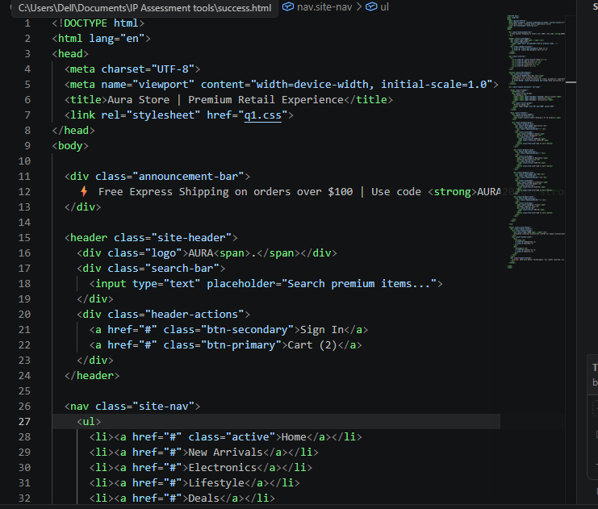

CSS Code:
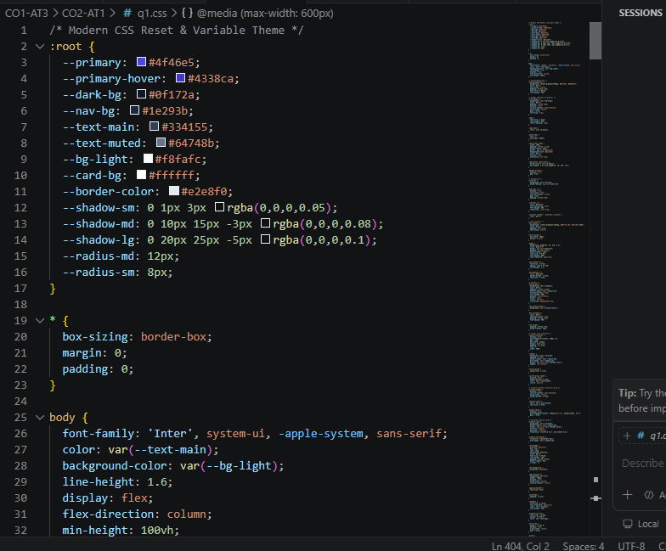

Output:


(e) Evaluation of Effectiveness & Further Suggested Improvements

Evaluation of Solution
- Fluid Grid Adaptability: Using repeat(auto-fit, minmax(230px, 1fr)) automatically calculates screen real estate and wraps product cards smoothly across any screen resolution without broken boundaries.
- Layout Structure Separation: Using CSS Grid for the macro layout (sidebar + main content container) combined with Flexbox for micro components (header items, nav link alignment, pricing rows) ensures structural stability.
- Modern Visual Hierarchy: Subtle hover states (transform: translateY(-6px)), CSS variable usage (:root), rounded card borders (12px), drop shadows, and dark-themed navigation sections deliver an intuitive, clean interface.

Further Suggested Improvements
- Dynamic Mobile Drawer: Implement a JavaScript-powered hamburger menu on screens under 600px to collapse navigation links into an accessible slide-out drawer, preserving screen real estate.
- Fluid Typography Scaling: Implement CSS clamp() functions (e.g., font-size: clamp(1.8rem, 4vw, 2.5rem);) for dynamic heading scaling across screens without reliance on media query breakpoints.
- Adaptive Image Delivery: Incorporate HTML5 <picture> elements paired with srcset attributes to deliver lightweight, WebP-formatted image formats tailored to mobile display densities, boosting loading speeds on mobile data.

Experiment 2: Form Validation using JavaScript

(a) Analysis of Issues in Existing Form Validation
When a registration form accepts invalid email addresses and phone numbers, it leads to corrupted user databases, failed notification delivery, and security vulnerabilities. Key flaws in naive validation mechanisms include:
- Generic Input Types: Using standard <input type="text"> instead of semantic <input type="email"> or <input type="tel"> fails to trigger mobile browser soft keymaps (like @ key or numeric keypads).
- Submit-Only Feedback: Validating data only upon submit button clicks forces users into a tedious cycle of submitting, waiting, reading errors, and re-submitting.
- Missing Pattern Matching: Accepting raw text strings without structural rules allows syntactically broken inputs (e.g., user@com or abc1234).
- Poor Error Messaging: Absence of dedicated DOM elements (<span> error targets) leaves users guessing what format is expected.
- Over-reliance on Client Validation: Relying solely on client-side checks without backend validation exposes systems to script bypass attacks using tools like cURL or Postman.

b) Input Fields Design with HTML5 Attributes
Using semantic types, placeholder guides, autocomplete, and required attributes ensures accessibility and browser-level initial checks.
<div class="form-group" id="emailGroup">
<label for="email">Email Address</label>
<input
type="email"
id="email"
name="email"
placeholder="e.g. alex@example.com"
required
autocomplete="email"
>
<span class="error-message" id="emailError"></span>
</div>

<div class="form-group" id="phoneGroup">
<label for="phone">Phone Number</label>
<input
type="tel"
id="phone"
name="phone"
placeholder="e.g. +1 1234567890 or 9876543210"
required
autocomplete="tel"
>
<span class="error-message" id="phoneError"></span>
</div>

(c) & (d) JavaScript Implementation with RegEx & Real-Time Error Display
Save the following code in index.html, styles.css, and script.js.
Code:
HTML:
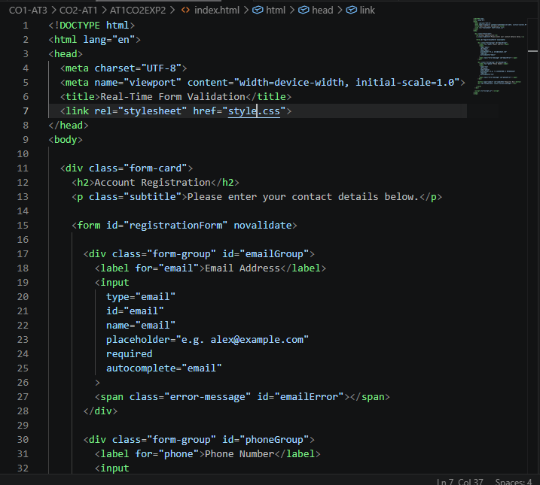
CSS:
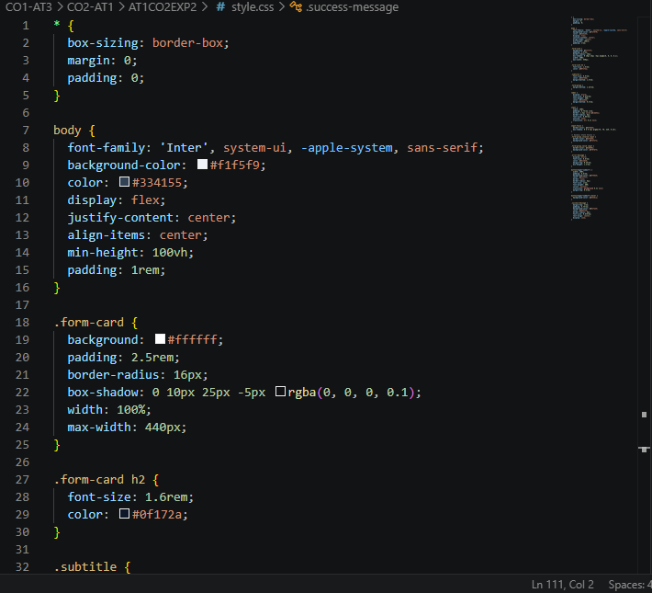
Java Script:
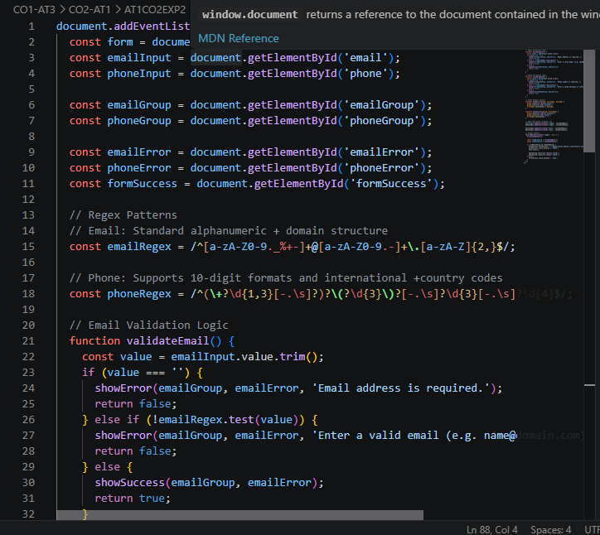

Output:


(e) Evaluation & System Enhancements

System Evaluation
- Immediate Real-Time Feedback: Listening to input and blur events prevents submission friction by guiding users right while typing.
- Precise Regular Expression Rules: Standard RFC-compliant email checks and flexible phone format matching reduce bad data entry.
- Accessibility & Visual Indicators: Contextual CSS class toggling (.valid / .invalid) visually signals state changes through color tints and dedicated text nodes.

Enhancements for UX & Security
- Server-Side Validation: Always re-validate all inputs on the backend server before database entry to prevent malicious script injection or API bypasses.
- Input Debouncing: Implement a ~300ms debounce function on real-time event listeners to optimize execution efficiency during rapid key presses.
- 2-Factor Verification (OTP): Combine structural RegEx validation with an SMS/Email OTP (One-Time Password) service to verify input ownership.
- ARIA Screen Reader Support: Dynamically toggle aria-invalid="true" and aria-describedby attributes for improved accessibility compliance.

Experiment 3: CSS Layout Debugging & Responsiveness

(a) Analysis of CSS Properties Causing Layout Overlapping
Layout overlapping occurs when elements breach their intended DOM boundaries during browser resizing. The root CSS causes include:
- Misuse of position: absolute & fixed: Absolute positioning removes elements completely from the normal document flow. Sibling elements render as if the absolute element does not exist, causing collisions when screen size changes.
- Hardcoded Pixel Dimensions (px): Setting fixed width or height values (e.g., width: 900px, height: 400px) prevents containers from flexing or wrapping as the browser viewport shrinks.
- Default Box-Sizing Model (content-box): Under the default content-box behavior, padding and borders are added on top of the declared width (Total Width = Specified Width + Padding + Border). A container set to width: 100% with padding: 20px will exceed 100% viewport width, breaking multi-column layouts and overlapping adjacent components.
- Uncleared Floating Elements: Legacy float: left layouts without proper clearfix containers collapse parent container heights to zero, letting lower section content slip underneath the floating elements.

(b) Role of the CSS Box Model in Layout Design
The CSS Box Model is the foundation of element rendering and layout calculation. Every rendered HTML element is treated as a rectangular box comprising four concentric layers:
- Content: The innermost area where text, images, or child elements reside.
- Padding: Clear area surrounding the content, inside the border boundary.
- Border: The edge surrounding the padding and content layers.
- Margin: Clear area outside the border, separating the element from neighboring elements.

Box Model Sizing Comparison
- box-sizing: content-box (Default):
$$\text{Rendered Width} = \text{Width} + \text{Padding Left/Right} + \text{Border Left/Right}$$
Issue: Causes width calculation errors during window resizing.
- box-sizing: border-box (Modern Standard):
$$\text{Rendered Width} = \text{Explicitly Set Width}$$
Advantage: Padding and borders are absorbed inside the width, eliminating unexpected container overflows and layout breaks.

(c) & (d) Debugging Strategy & Modified CSS Code
To resolve layout collisions:
- Global box-sizing: border-box is enforced.
- Absolute positioning is replaced with Flexbox for 1D alignments and CSS Grid for 2D multi-column layouts.
- Flex limits (flex: 1 1 240px) and auto-fit column definitions are added to ensure fluid wrapping.

Code:
HTML:
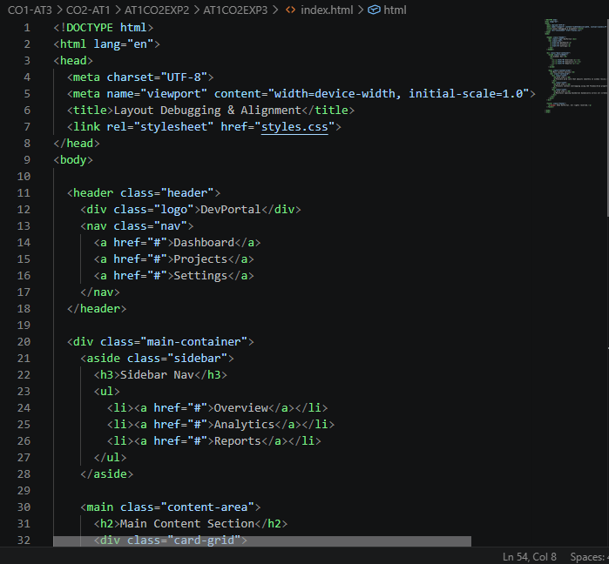
CSS:
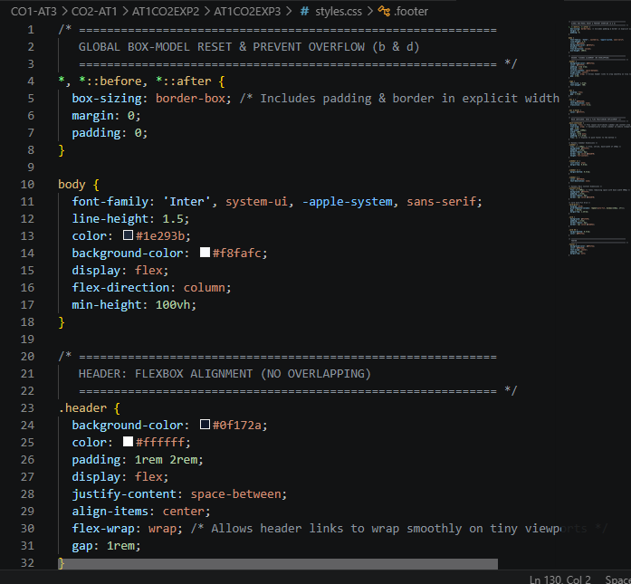

Output:
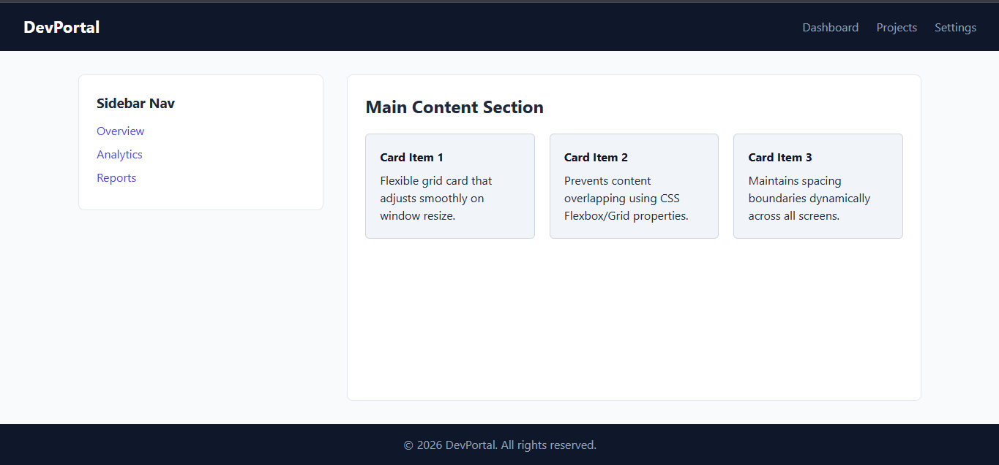

(e) Layout Evaluation & Best Practices

Evaluation of Corrected Layout
- Fluid Flow Adaptability: Replacing static width: px with Flexbox properties (flex: 1 1 240px) and CSS Grid (repeat(auto-fit, minmax(220px, 1fr))) allows content to reflow naturally without overlapping during window resize.
- Controlled Document Flow: Eliminating position: absolute on core page containers ensures every element respects sibling boundaries.
- Predictable Sizing Calculations: Applying box-sizing: border-box globally ensures container padding never breaks maximum width limits.

Best Practices for Layout Consistency
- Global Box-Model Reset: Always initialize stylesheets with *, *::before, *::after { box-sizing: border-box; }.
- Use Relative Units: Prefer percentages (%), root ems (rem), fractional units (fr), and viewport units (vw/vh) over hardcoded pixel dimensions.
- Restrict Absolute Positioning: Reserve position: absolute exclusively for non-structural UI overlays like popups, tooltips, dropdown menus, or icon badges.
- Leverage Modern CSS Layout Engines: Combine CSS Grid for 2D structural layouts (main layout areas) with Flexbox for 1D component positioning (headers, navbars, button groups).
- Responsive DevTools Testing: Regularly inspect layouts across standard viewport breakpoints (375px, 768px, 1024px, 1440px) to identify alignment bottlenecks early.

